HW1

姓名：蔡育嘉 學號：D0641798

模糊圖片 (Average Blur、Medium Blur、Gaussian Blur)

# 一、程式碼：

|  |
| --- |
| import cv2 import numpy as np import skimage from skimage.viewer import ImageViewer import sys import math  img=cv2.imread("C:/Users/user/Desktop/imageprocess/HW1/cat.jpg")  cv2.imshow("Original",img)  print(img.shape)  filter_size=3 #這邊可以改size extend_size=int((filter_size-1)/2)# 算要額外增加一圈的矩陣寬度是多少 # filter size= 3-> 1 增加一圈 # filter size= 5-> 2 增加二圈 以此類推  img_len,img_width,img_channels=img.shape  y=np.zeros([img_len+(extend_size*2),img_width+(extend_size*2),img_channels],dtype="uint8") #增加兩圈 陣列上下左右增加2倍  for channel in range(img_channels):  for i in range(extend_size,img_len+extend_size):  for j in range(extend_size,img_width+extend_size): # 把圖片放進四周圍pixel值為0中  y[i][j][channel]=img[i-extend_size][j-extend_size][channel]   #卷積運算 def average_blur(img,filter_size):  img_len,img_width,img_channels=img.shape  convolution=np.ones([filter_size,filter_size,img_channels])  for channel in range(img_channels):  for i in range(img_len):  for j in range(img_width):  temp=0  for filter_X in range(filter_size):  for filter_Y in range(filter_size):  temp=temp+y[i+filter_X][j+filter_Y][channel]*convolution[filter_X][filter_Y][channel]  img[i][j][channel]=round(temp/(filter_size*filter_size))   signature=cv2.imread("C:/Users/user/Desktop/imageprocess/HW1/signature_cat.png")  signature_x,signature_y,signature_channels=signature.shape  for channel in range(signature_channels):  for i in range(signature_x):  for j in range(signature_y):  if signature[i][j][channel]==0:#如果簽名檔為黑 則self_blur同位置也是黑的  img[i][j][channel]=0  cv2.imshow("self_average_blur",img)  cv2.waitKey()  #找中位數 def median_blur(img,filter_size):  img_len,img_width,img_channels=img.shape  for channel in range(img_channels):  for i in range(img_len):  for j in range(img_width):  temp=[]  for filter_X in range(filter_size):  for filter_Y in range(filter_size):  temp.append(y[i+filter_X][j+filter_Y][channel])  temp.sort() #把filter內的數字排列之後  half=int(len(temp)/2)#找index一半的元素  img[i][j][channel]=temp[half]   signature=cv2.imread("C:/Users/user/Desktop/imageprocess/HW1/signature_cat.png")  signature_x,signature_y,signature_channels=signature.shape  for channel in range(signature_channels):  for i in range(signature_x):  for j in range(signature_y):  if signature[i][j][channel]==0:#如果簽名檔為黑 則self_blur同位置也是黑的  img[i][j][channel]=0  cv2.imshow("self_median_blur",img)  cv2.waitKey()  def gaussian_blur(img,filter_size):   blur = cv2.GaussianBlur(img, (filter_size, filter_size),0)  signature=cv2.imread("C:/Users/user/Desktop/imageprocess/HW1/signature_cat.png")  signature_x,signature_y,signature_channels=signature.shape  for channel in range(signature_channels):  for i in range(signature_x):  for j in range(signature_y):  if signature[i][j][channel]==0:#如果簽名檔為黑 則self_blur同位置也是黑的  img[i][j][channel]=0  cv2.imshow("gaussian_blur",img)  cv2.waitKey()    average_blur(img,filter_size) median_blur(img,filter_size) gaussian_blur(img,filter_size) |

# 二、執行結果：

# 

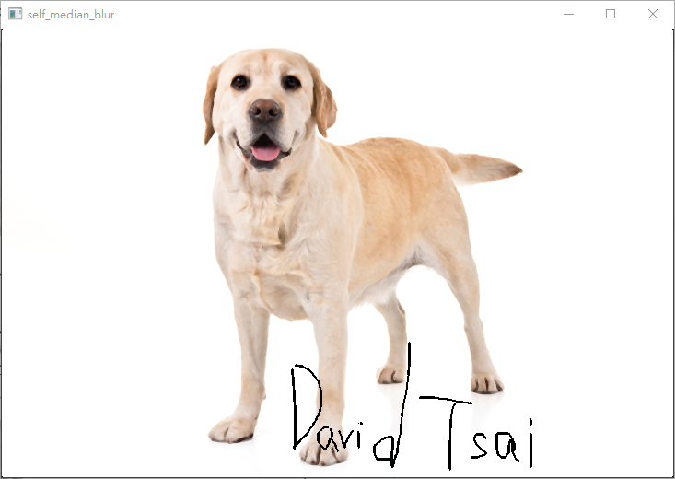

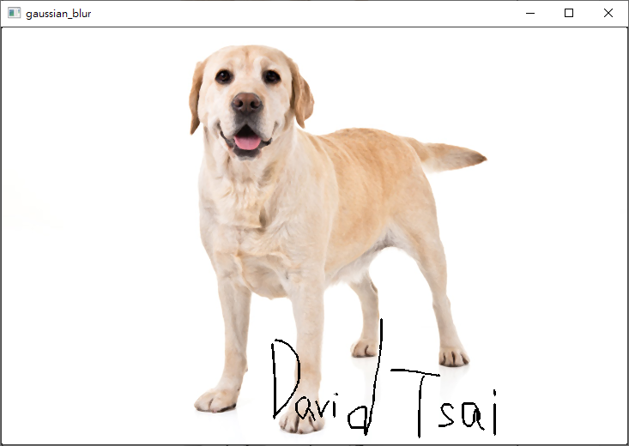

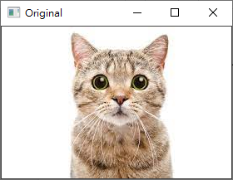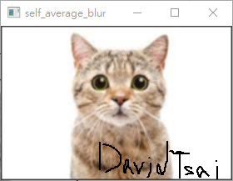

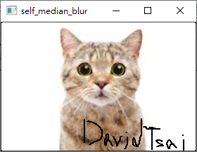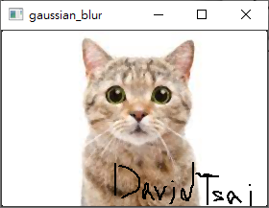

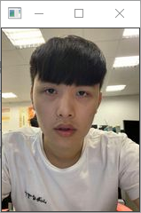

原圖

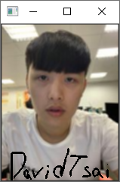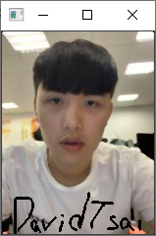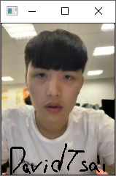

average_blur median_blur gaussian_blur

**比較分析三種模糊方法在人臉照片下的差別**

上面三種是用filter_size=3的參數去執行，average_blur的模糊程度最高，median_blur跟gaussian_blur的效果，肉眼看起來很像，最主要的差別我認為是像在臉頰的地方，median_blur如果框到的地方都是皮膚色居多，陰影的地方就不會顯示出來，而gaussian_blur在臉頰的部分，看起來多了陰影，沒有像medain_blur的圖片來得紅潤。

# 縮放圖片(最近鄰、線性)

# 一、程式碼：

|  |
| --- |
| import numpy as np import cv2 from math import sqrt  import math  #img 原圖  #time 縮放倍數 def interpolation(img,time):  height,width,channels =img.shape  new_height=int(height*time)  new_width=int(width*time)   emptyImage=np.zeros((new_height,new_width,channels),dtype=np.uint8)  # -------  # | A B |  # | C D |  # -------  #  # -----------  # | A B |  # | |  # | |  # | C D |  # -----------  for channel in range(channels):  for y in range(new_height):  for x in range(new_width):    src_X=x/time  src_Y=y/time  if src_X%1==0 and src_Y%1==0: #如果XY是整數 就直接取元圖對應到的index  src_X=int(src_X)  src_Y=int(src_Y)  emptyImage[y][x][channel]=img[src_Y][src_X][channel]   else:  A_x=int(src_X)  A_y=int(src_Y)   B_x=A_x+1  B_y=A_y   C_x=A_x  C_y=A_y+1   D_x=A_x+1  D_y=A_y+1    if D_y>=height: #D超過的時候 微調ABCD座標  D_y=height-1  C_y=height-1  A_y=C_y-1  B_y=D_y-1  if D_x>=width:  D_x=width-1  B_x=width-1  A_x=B_x-1  C_x=D_x-1   A=img[A_y][A_x][channel]  B=img[B_y][B_x][channel]  C=img[C_y][C_x][channel]  D=img[D_y][D_x][channel]   A=int(A)  B=int(B)  C=int(C)  D=int(D)    w=x-(A_x*time)  W=(B_x-A_x)*time  h=y-(A_y*time)  H=(C_y-A_y)*time   i=A+(w*(B-A)/W)  j=C+((w*(D-C))/W)    pixel=i+((h*(j-i))/H)  emptyImage[y][x][channel]=pixel    return emptyImage    def interpolation_test(img,time):  height,width,channels =img.shape  new_height=int(height*time)  new_width=int(width*time)   emptyImage=np.zeros((new_height,new_width,channels),dtype=np.uint8)  # -------  # | A B |  # | C D |  # -------  #  # -----------  # | A B |  # | |  # | |  # | C D |  # -----------  for channel in range(channels):  for y in range(new_height):  for x in range(new_width):    src_X=x/time  src_Y=y/time  if src_X%1==0 and src_Y%1==0: #如果XY是整數 就直接取元圖對應到的index  src_X=int(src_X)  src_Y=int(src_Y)  emptyImage[y][x][channel]=img[src_Y][src_X][channel]   else:  A_x=int(src_X)  A_y=int(src_Y)   B_x=A_x+1  B_y=A_y   C_x=A_x  C_y=A_y+1   D_x=A_x+1  D_y=A_y+1    if D_y>=height: #D超過的時候 微調ABCD座標  D_y=height-1  C_y=height-1  A_y=C_y-1  B_y=D_y-1  if D_x>=width:  D_x=width-1  B_x=width-1  A_x=B_x-1  C_x=D_x-1   A=img[A_y][A_x][channel]  B=img[B_y][B_x][channel]  C=img[C_y][C_x][channel]  D=img[D_y][D_x][channel]   A=int(A)  B=int(B)  C=int(C)  D=int(D)    w=x-(A_x*time)  W=(B_x-A_x)*time  h=y-(A_y*time)  H=(C_y-A_y)*time  #先從y方向算 再算x  i=A+(h*(C-A)/H)  j=B+((h*(D-B))/H)    pixel=i+((w*(j-i))/W)  emptyImage[y][x][channel]=pixel    return emptyImage def nearest(img,time):  height,width,channels =img.shape   new_height=int(height*time)  new_width=int(width*time)  # -------  # | A B |  # | C D |  # -------   # -----------  # | A B |  # | |  # | |  # | C D |  # -----------  emptyImage=np.zeros((new_height,new_width,channels),dtype=np.uint8)  for channel in range(channels):  for i in range(new_height):  for j in range(new_width):  y=int(i/time) #除放大或縮小的倍率  x=int(j/time) #取整數  emptyImage[i][j][channel]=img[y][x][channel]   return emptyImage   img=cv2.imread("C:/Users/user/Desktop/imageprocess/HW1/me.jpg")  print(img.shape) self_interpolation=interpolation(img,2)  self_nearest=nearest(img,2) self_interpolation_test=interpolation_test(img,2)  signature=cv2.imread("C:/Users/user/Desktop/imageprocess/HW1/signature_me.png")    signature=interpolation(signature,2) signature_y,signature_x,channels=signature.shape for channel in range(channels):  for y in range(signature_y):  for x in range(signature_x):  if signature[y][x][channel]==0:#如果簽名檔為黑 則nearest_neighbor同位置也是黑的  self_interpolation[y][x][channel]=0  self_interpolation_test[y][x][channel]=0  self_nearest[y][x][channel]=0  self_interpolation_height,self_interpolation_width,channels=self_interpolation.shape for channel in range(channels):  for y in range(self_interpolation_height):  for x in range(self_interpolation_width):  if self_interpolation[y][x][channel]!=self_interpolation_test[y][x][channel]:  print(self_interpolation[y][x][channel])  print(self_interpolation_test[y][x][channel])   print("OK") cv2.imshow("self_interpolation",self_interpolation) #cv2.imshow("self_interpolation_test",self_interpolation_test)      cv2.imshow("self_nearest",self_nearest) cv2.imshow("image",img) cv2.waitKey(0) |

# 二、執行結果：

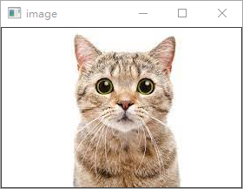

放大兩倍

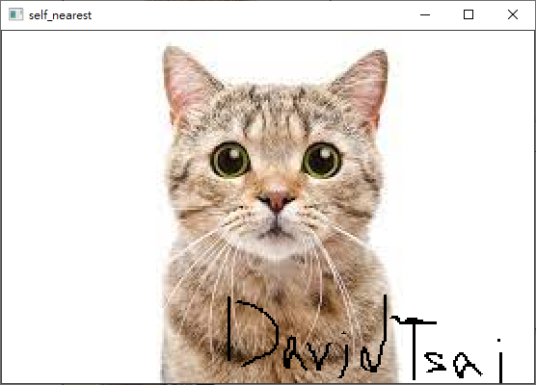

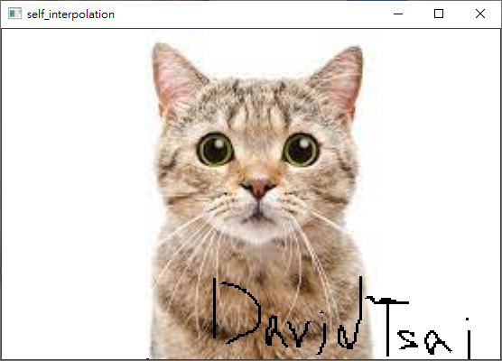

縮小2倍

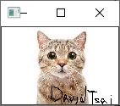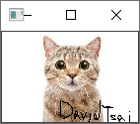

最近鄰 內插

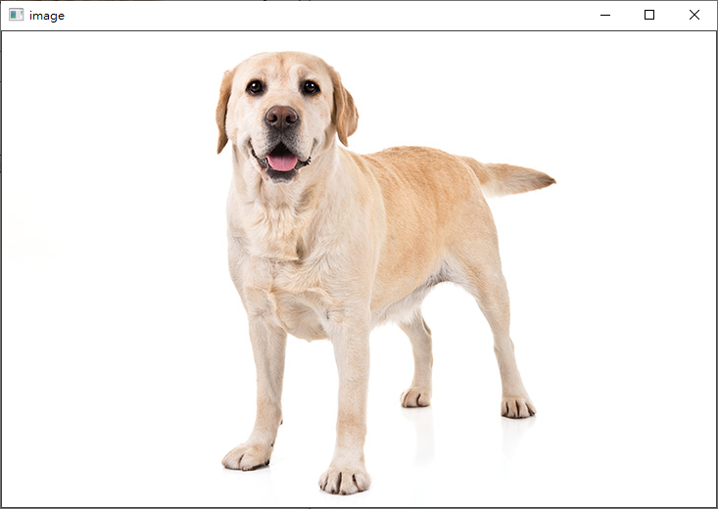

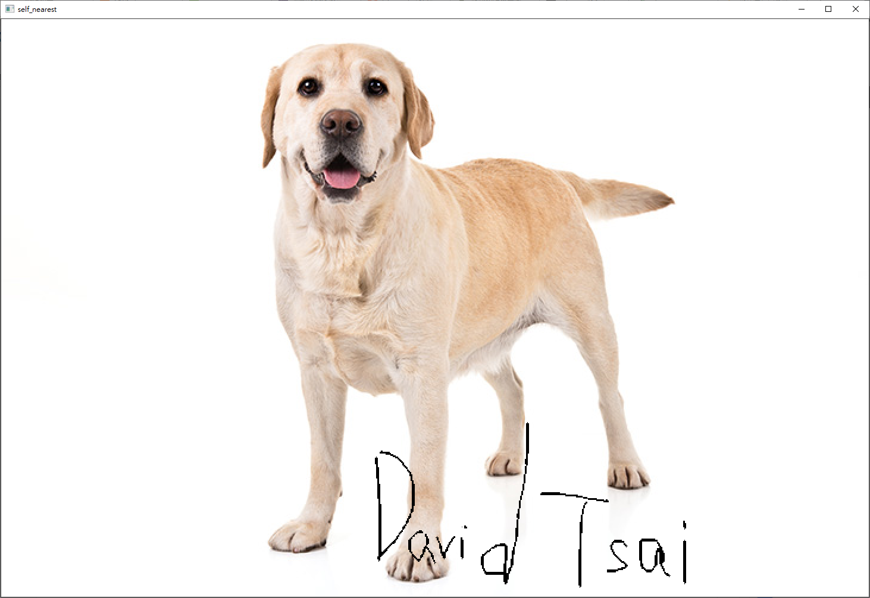

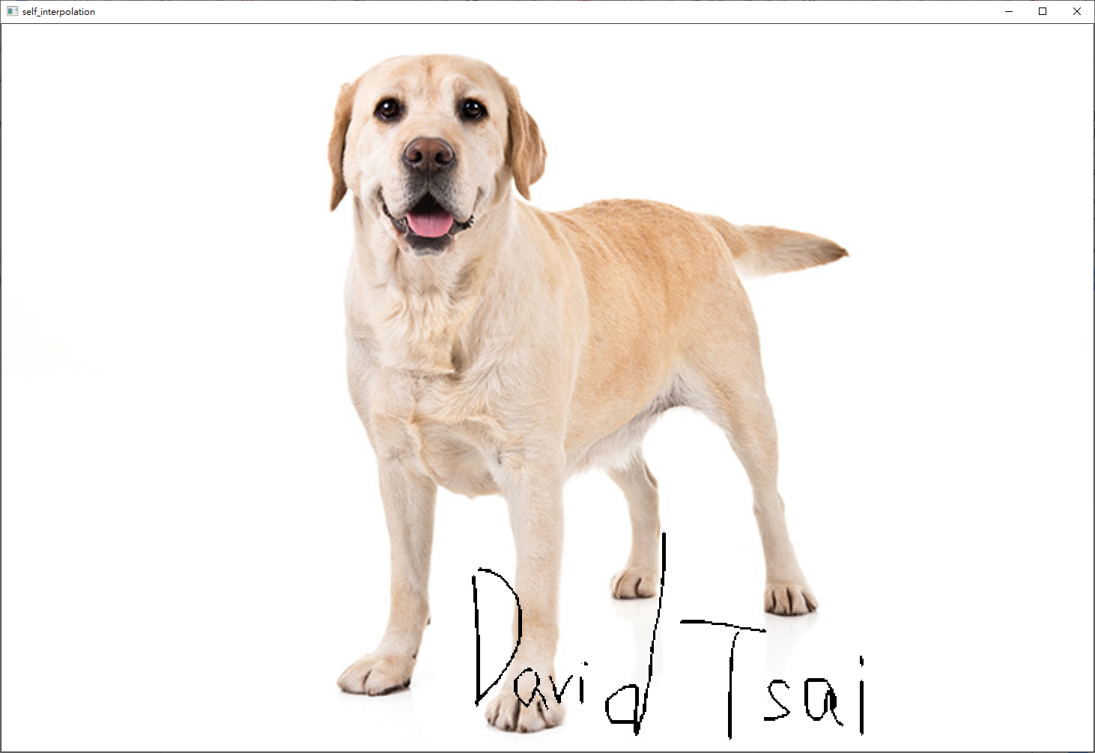

這邊圖片太大了，我貼上來只能這樣，不過他整個視窗比例有變化

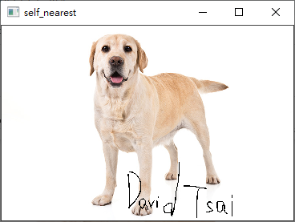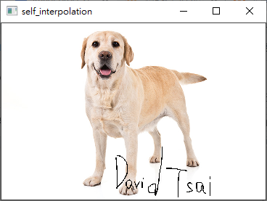

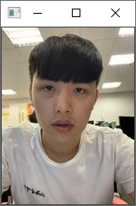

原圖

放大兩倍

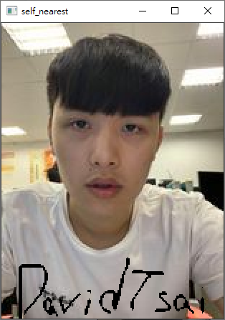

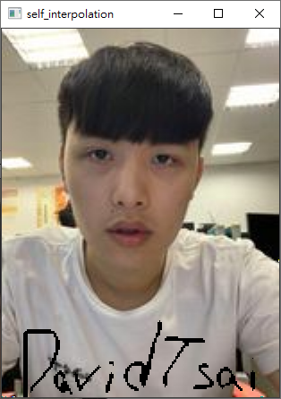

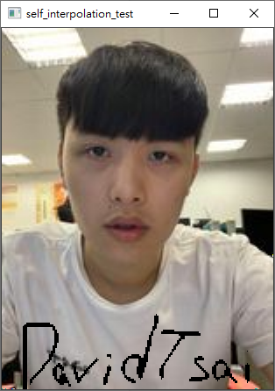

縮小2倍

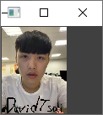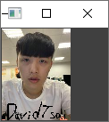

最近鄰 內插

**比較線性內插時從不同方向進行內插的結果**

我分別從兩個方向同時做內插，接著把內插結束的圖片，比較每個pixel出來的值是一樣的

